State of Nebraska Department of Health and Human Services

REQUEST FOR INFORMATION

RETURN TO:
Keith Roland
301 Centennial Mall S., LL
Lincoln, NE 68508
(402) 471-0727
DHHS.Procurement@nebraska.gov

SOLICITATION NUMBER | RELEASE DATE
RFI 1511 | September 5, 2019
OPENING DATE AND TIME | PROCUREMENT CONTACT
September 30, 2019 2:00 p.m. Central Time | Keith Roland
This form is part of the specification package and must be signed in ink and returned, along with information documents, by the opening date and time specified.
PLEASE READ CAREFULLY!
SCOPE OF SERVICE
The State of Nebraska (State), Department of Health and Human Services (DHHS), is issuing this Request for Information RFI 1511 for the purpose of gathering information for Cancer Registry Quality Assurance, Data Collection and Data Management.

Written questions are due no later than September 12, 2019, and should be submitted via e-mail to dhhs.procurement@nebraska.gov.

Bidder should submit an electronic copy of the entire RFI response to DHHS.Procurement@nebraska.gov. RFI responses should be submitted by the RFI due date and time.

Sealed RFI responses should be received by DHHS by the date and time of RFI opening indicated above.

TABLE OF CONTENTS

REQUEST FOR INFORMATION i
TABLE OF CONTENTS ii
I. SCOPE OF THE REQUEST FOR INFORMATION 1
A. SCHEDULE OF EVENTS 1
II. RFI RESPONSE PROCEDURES 2
A. OFFICE AND CONTACT PERSON 2
B. GENERAL INFORMATION 2
C. COMMUNICATION WITH STATE STAFF 2
D. WRITTEN QUESTIONS AND ANSWERS 2
E. ORAL INTERVIEWS/PRESENTATIONS AND/OR DEMONSTRATIONS 3
F. SUBMISSION OF RESPONSE 3
G. PROPRIETARY INFORMATION 3
H. REQUEST FOR INFORMATION OPENING 3
III. PROJECT DESCRIPTION AND SCOPE OF WORK 4
A. PURPOSE 4
B. BACKGROUND 4
C. CURRENT BUSINESS PRACTICES 4
D. CURRENT ENVIRONMENT 6
E. SYSTEM OVERVIEW 8
F. ANTICIPATED REQUIRED SERVICES 10
G. RESPONDENT QUESTIONS 13
Form A Vendor Contact Sheet 16

- SCOPE OF THE REQUEST FOR INFORMATION

The State of Nebraska, Department of Health and Human Services (DHHS), is issuing this Request for Information, RFI 1511 for the purpose of gathering information to for Cancer Registry Quality Assurance, Data Collection and Data Management.

ALL INFORMATION PERTINENT TO THIS REQUEST FOR INFORMATION CAN BE FOUND ON THE INTERNET AT: http://das.nebraska.gov/materiel/purchasing.html and
http://dhhs.ne.gov/Pages/Grants-and-Contract-Opportunities.aspx

  - SCHEDULE OF EVENTS
The State expects to adhere to the tentative procurement schedule shown below. It should be noted, however, that some dates are approximate and subject to change.

ACTIVITY |  | DATE/TIME
1 | Release Request for Information | 09/05/2019
2 | Last day to submit written questions | 09/12/2019
3 | State responds to written questions through Request for Information “Addendum” and/or “Amendment” to be posted to the internet at:  http://das.nebraska.gov/materiel/purchasing.html | 09/23/2019
4 | RFI opening  Location: DHHS Central Procurement Services  301 Centennial Mall S., Lower Level  Lincoln, NE 68508 | 09/30/2019  2:00 PM  Central Time
5 | Conduct oral interviews/presentations and/or demonstrations (if required) | To Be Determined

- RFI RESPONSE PROCEDURES

  - OFFICE AND CONTACT PERSON
Responsibilities related to this Request for Information reside with the State Purchasing Bureau. The point of contact for the RFI is as follows:

Name: Keith Roland
Agency: DHHS Central Procurement Services
Address: 301 Centennial Mall S., Lower Level
Lincoln, NE 68508
Telephone: 402-471-60727
E-Mail: dhhs.procurement@nebraska.gov

  - GENERAL INFORMATION
A subsequent Request for Proposal (RFP) may not be issued as a result of this RFI. There will not be a contract as a result of this RFI and the State is not liable for any cost incurred by respondents in replying to this RFI. If an RFP is issued, the information provided will assist the State of Nebraska in developing the Request for Proposal. This RFI does not obligate the State to reply to the RFI responses, to issue an RFP, or to include any RFI provisions or responses provided by respondents in any RFP.

  - COMMUNICATION WITH STATE STAFF
From the date the Request for Information is issued and until RFI opening (as shown in the Schedule of Events), contact regarding this RFI between potential respondents and individuals employed by the State should be restricted to written communication with the staff designated above as the point of contact for this Request for Information.

The following exceptions to these restrictions are permitted:

    - Written communication with the person(s) designated as the point(s) of contact for this Request for Information;
    - Contacts made pursuant to any pre-existing contracts or obligations; and
    - State-requested presentations, key personnel interviews, clarification sessions, or discussions.

Violations of these conditions may be considered sufficient cause to reject a respondent’s response to the RFI. No individual member of the State, employee of the State, or member of the Interview Committee is empowered to make binding statements regarding this RFI. The State of Nebraska will issue any clarifications or opinions regarding this RFI in writing.

  - WRITTEN QUESTIONS AND ANSWERS
Any explanation desired by a respondent regarding the meaning or interpretation of any Request for Information provision should be submitted in writing to DHHS and clearly marked “RFI Number 1511; Cancer Registry Questions”. It is preferred that questions be sent via e-mail to dhhs.procurement@nebraska.gov.

It is recommended that Bidders submit questions sequentially numbered, include the RFI reference and page number using the following format.

Question Number | RFI Section Reference | RFI Page Number | Question

Written answers will be provided through an addendum to be posted on the Internet at http://das.nebraska.gov/materiel/purchasing.html on or before the date shown in the Schedule of Events.

  - ORAL INTERVIEWS/PRESENTATIONS AND/OR DEMONSTRATIONS

The State reserves the right to conduct oral interviews/presentations and/or demonstrations if required at the sole invitation of the State.

Any cost incidental to the oral interviews/presentations and/or demonstrations shall be borne entirely by the respondent and will not be compensated by the State

  - SUBMISSION OF RESPONSE
The following describes the requirements related to the RFI submission, handling and review by the State.

To facilitate the response review process, an electronic copy of the entire RFI response should be submitted to DHHS.Procurement@nebraska.gov. RFI responses should be submitted by the RFI due date and time.

A separate sheet must be provided that clearly states which sections have been submitted as proprietary or have copyrighted materials. RFI responses should reference the request for information number and be sent to the specified address. Please note that the address label should appear as specified on the face of each container. If a recipient phone number is required for delivery purposes, 402-471-0727 should be used. The Request for Information number must be included in all correspondence.

  - PROPRIETARY INFORMATION
Data contained in the response and all documentation provided therein, become the property of the State of Nebraska and the data become public information upon opening the response. If the vendor wishes to have any information withheld from the public, such information must fall within the definition of proprietary information contained within Nebraska’s public record statutes. All proprietary information the respondent wishes the state to withhold must be submitted in a sealed package, which is separate from the remainder of the response. The separate package must be clearly marked PROPRIETARY on the outside of the package. Respondent may not mark their entire Request for Information as proprietary. Failure of the vendor to follow the instructions for submitting proprietary and copyrighted information may result in the information being viewed by other respondents and the public. Proprietary information is defined as trade secrets, academic and scientific research work which is in progress and unpublished, and other information which if released would give advantage to business competitors and serve no public purpose (see Neb. Rev. Stat. § 84-712.05(3)). In accordance with Attorney General Opinions 92068 and 97033, vendors submitting information as proprietary may be required to prove specific, named competitor(s) who would be advantaged by release of the information and the specific advantage the competitor(s) would receive. Although every effort will be made to withhold information that is properly submitted as proprietary and meets the State’s definition of proprietary information, the State is under no obligation to maintain the confidentiality of proprietary information and accepts no liability for the release of such information.

  - REQUEST FOR INFORMATION OPENING
The sealed responses will be publicly opened and the responding entities announced on the date, time, and location shown in the Schedule of Events. Responses will be available for viewing by those present after the opening. Respondents may also contact the state to schedule an appointment for viewing RFI responses.
- PROJECT DESCRIPTION AND SCOPE OF WORK

  - PURPOSE
The Nebraska Department of Health and Human Services (DHHS) is currently seeking information regarding services for State Cancer Registry data collection, data management, and quality assurance for the State of Nebraska in accordance with the data requirements set forth by State statute in Neb. Rev. Stat. §§ 81-642 to 81-650 (https://nebraskalegislature.gov/laws/statutes.php?statute=81-642); Public Law 102-515 (https://www.cdc.gov/cancer/npcr/npcrpdfs/publaw.pdf); the standards set by the National Program of Cancer Registries (NPCR)
(https://www.cdc.gov/cancer/npcr/pdf/npcr_standards.pdf); and the North American Association of Central Cancer Registries (NAACCR) (https://www.naaccr.org).

  - BACKGROUND
Monitoring the occurrence of cancer is a cornerstone of cancer control decision-making. This monitoring, referred to as cancer surveillance, can be used to trigger case investigations, follow trends, evaluate the effectiveness of prevention measures such as screening and early detection programs, and suggest public health priorities. As an integral part of the Nebraska cancer surveillance program, the DHHS Nebraska Cancer Registry (NCR) was founded in 1986 (Neb. Rev. Stat. § 81-638) when the Nebraska Unicameral authorized funding for a state cancer registry. A portion of funds generated by the state’s cigarette tax was used to establish a system to collect and analyze information pertaining to cancers. Since 1994, the DHHS NCR has received additional funding from the Centers for Disease Control and Prevention (CDC). The purpose of the registry is to gather data that describes how many Nebraska residents are diagnosed with cancer, what types of cancer they have, how far the disease has advanced at the time of diagnosis, what types of treatment they receive, and how long they survive after diagnosis.

Nationally, the majority of state cancer registries are transitioning to electronic submission and consolidation of data to improve the completeness, timeliness, consistency and efficiency with which cancer data are transmitted, received and processed. The State of Nebraska DHHS is developing a pathway to achieve electronic submission and processing of cancer registry data.

  - CURRENT BUSINESS PRACTICES

  - Reporting Law. The DHHS NCR collects, maintains, and reports data on cancer incidence in the State of Nebraska as mandated by § 81-642 to 81-650. The law mandates that all hospitals and providers shall report cancer data within six months from the initial diagnosis to the State and that the State shall establish and maintain a cancer registry that includes a record of all the cases of cancer that occur within the state and such information concerning these cases which the department determines necessary and appropriate to provide a basic source of information to further scientific and medical research for the prevention, cure, and control of cancer.

  - DHHS NCR Operations. The DHHS NCR is administered and maintained by the DHHS located in Lincoln and currently contracted with a service provider for data collection, processing and quality assurance. In addition to custodial oversight of the NCR, the DHHS oversees administrative and technical aspects of the operations. The current contractor office receives, processes, and consolidates all cancer reports for each cancer occurrence into an individual tumor record; manages the DHHS NCR Internet portal, software and master database; and performs auditing and quality assurance/quality control activities. DHHS maintains the complete database and utilizes the data to generate statistical reports and fact sheets and fulfills data requests from internal and external partners of the DHHS NCR.

  - Data Submission. Data are received either via secure emails or file upload on a secure site online. For reporters with a low annual cancer caseload (defined as less than 50 cases) hard copy reports are accepted. These facilities are required to submit the data elements to the DHHS NCR current contractor that will perform the data abstraction. There are very minimal amounts of electronic data being captured and the vast majority of the information received requires manual abstraction and entry into the system. Hospitals with more than 50 cases/year are required to abstract their data and then send it to the DHHS NCR current contractor. See pathology data flow diagram below under System Overview.
- Future Considerations:
  - Electronic submission of pathology reports from State Laboratories is underway to provide these to the DHHS NCR current contractor for abstraction.

  - DHHS NCR Software. All DHHS NCR data are processed and stored in Rocky Mountain Cancer Data System (RMCDS) developed by the University of Utah. The RMCDS provides technical consultations and upgrades to the software. Software and hardware maintenance and technical consultation are performed by both DHHS and the current contractor.
- The current system used for data abstraction is the Rocky Mountain Cancer Data System (RMCDS) provided through University of Utah that is also used by approximately 20 other states.
- Future Considerations:
  - DHHS is currently testing to use eMaRC Plus developed by the CDC to create abstracts from electronic reports (HL7 format) received from laboratories and physicians’ offices.
  - Other CDC systems considered for use include Abstract Plus and Registry Plus.

  - National Program Standards. The DHHS NCR is a member of North American Association of Central Cancer Registries (NAACCR) and the CDC’s NPCR and strives to ensure that all central registry operations are in compliance with both NAACCR and NPCR standards. The NAACCR program standards are included in the following documents: NAACCR Standards for Cancer Registries, Volume II: Data Standards and Data Dictionary, and NAACCR Standards for Cancer Registries, Volume III: Standards for Completeness, Quality, Analysis, and Management of Data. Both documents are available for download from the NAACCR website: www.NAACCR.org. The NPCR programs standards are available for download from the website: https://www.cdc.gov/cancer/npcr/standards.htm

  - Annual Data Quality Review and Certification. The DHHS NCR data are evaluated for certification by NAACCR on an annual basis, using the most recent complete year of incidence data. The purpose of the review is to certify the data are complete, accurate, and timely and are sufficient to use in the calculation of standard incidence statistics. The DHHS NCR has been awarded Gold Certification for 22 consecutive years since 1995. This criteria is available on the NAACCR site via https://www.naaccr.org/certification-criteria/.

The DHHS NCR data (i.e. 23 month and 12 month data) are also submitted to CDC’s NPCR for evaluation each year, and the NPCR standards are listed in https://www.cdc.gov/cancer/npcr/standards.htm.

  - Submission of Records to the DHHS NCR. The DHHS NCR has been using web-based reporting for more than a decade, and all hospitals submit data via file upload using Web Plus. As noted above, reporters with a low annual cancer caseload (defined as less than 50 cases) are permitted to submit reports using paper forms.
- Future Considerations:
The DHHS NCR aims to transition these facilities to electronic submission within the next three (3) years.

  - Audits. Currently quality assurance audits through re-case finding and re-abstracting are completed by the current contractor for Nebraska hospitals on a rotating three (3) year basis. Reporting facilities receive a written report on audit results. Additionally, the DHHS NCR itself is audited by CDC’s NPCR at least once every five (5) years.

  - Annual Reports. The DHHS publishes an annual report on cancer burdens (including cancer incidence and mortality) in Nebraska, and is required to deliver a fiscal year report to CDC’s NPCR. See the web site link below.

  - Web Site. The DHHS NCR maintains a web site which is located at: http://dhhs.ne.gov/Pages/Cancer-Registry.aspx

  - CURRENT ENVIRONMENT
The current NCR contractor performs the following services:

- Data Collection
- Data Instruction Manuals have been distributed to all hospitals listing the diagnoses that are reportable and what information needs to be reported on all cancer patients treated in their facility.
- Hospital tumor registries are requested to submit completed abstracts on a monthly basis. These abstracts are edited for errors and merged into the DHHS NCR.
- Low caseload hospitals are requested to submit chart copies when documentation is complete. These charts are abstracted and entered into the DHHS NCR.
- Pathology laboratories are expected to submit any report with a cancer diagnosis within six (6) months of the initial diagnosis to the DHHS NCR current contractor.
- If the cases are submitted through a physician’s office or clinic, the patient information will be requested from them and abstracted and entered into the DHHS NCR.
- Any facility not submitting reports/abstracts on a regular basis is contacted.
- Approximately ten thousand (10,000) new cancer cases are identified in Nebraska annually.
- Two hundred forty eight (248) facilities report cancer registry data to the DHHS NCR. Twenty one (21) pathology labs also report data.

- Visual Editing
- After adding hospital submissions to the DHHS NCR, all questionable, merged and multiple sequenced abstracts are reviewed.
  - Quality control of new data involves a visual review of data fields and the review of edit errors identified either by visual survey or by the computerized edits.
- RMCDS stem edits and Standard Edits are run on all hospital submissions. Corrections are made consistent with text in the hospital abstract in order to correct the edit.
  - Stem edits are edits tools within RMCDS software that checks the consistency and accuracy of the data naming conventions.
  - Standard Edits are edit tools provided by NAACCR for cancer registries to check on the completeness of data in meeting the NAACCR standards.
- Visual editing is done on cases submitted from hospital registries as needed.

- Monitoring
- Cases that are received and processed into the state cancer registry are monitored on a monthly basis. This includes cases by registry hospitals, non-registry hospitals, specialty clinics, other report sources, and other state registries.
- Death certificates received from DHHS and cases submitted by the Veterans’ Administration are processed and monitored on an annual basis.
- The case submission method (electronic or paper) is monitored on a monthly basis.
- Future Considerations:
  - For facilities that cannot meet 95% accuracy and/or completeness in abstracting, a quality improvement plan will be developed and reviewed and a follow-up audit will be conducted to document improvement.

- Data Submission
- An electronic copy of the NCR data set is sent to DHHS on a monthly basis.
- Data is submitted on an annual basis to both the NAACCR and to the CDC’s NPCR.
  - The preparation of these files includes correcting edits and finding duplicate cases.
  - The instructions are specified by NAACCR and NPCR. The software for the data submission is provided by RMCDS and NAACR.

- Reporting:
- Comprehensive quarterly and annual NCR reports on data collection activities are sent to the Nebraska DHHS. This includes findings from monitoring activities and other activities of the state tumor registry.
- An annual NCR work plan outlining the data collection activities is sent to the Nebraska DHHS.

- Education:
- Education and reinforcement is provided to tumor registry and medical record staff as needed.
- Education by way of NAACCR and NCRA webinars are made available to DHHS NCR personnel.
- Information on data collection and feedback from NPCR and NAACCR is presented at the annual meeting of the Tumor Registrars’ Association of Nebraska (TRAN).
- The Nebraska Data Acquisition Manual is updated and distributed to reporting hospitals as needed.

  - SYSTEM OVERVIEW

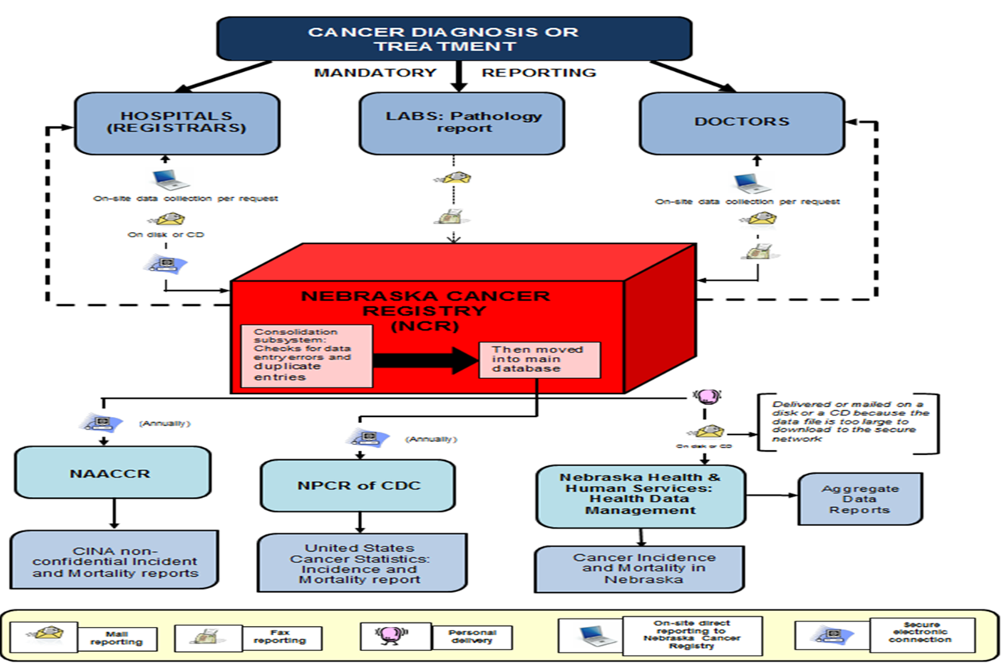

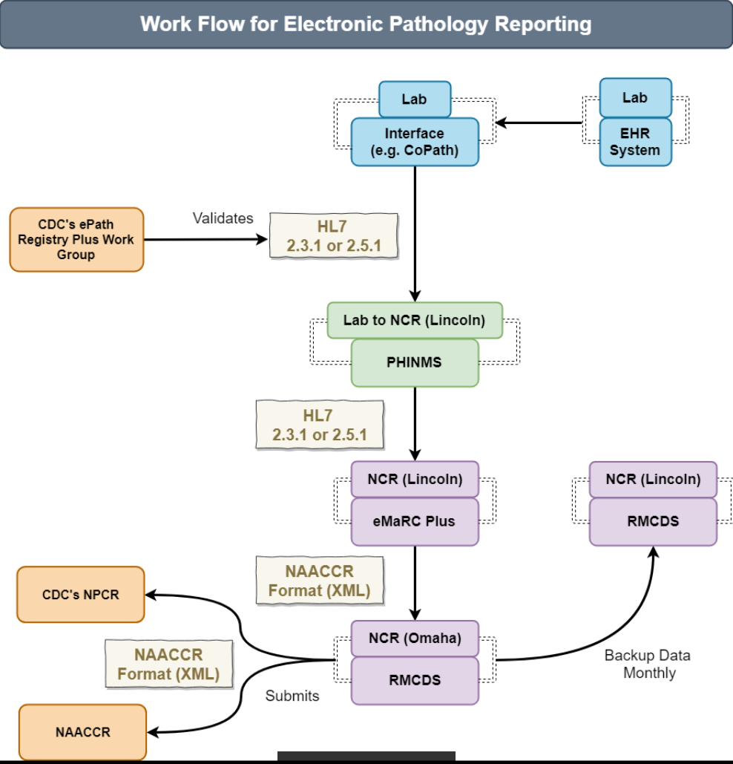

  - ANTICIPATED REQUIRED SERVICES
The majority of State Cancer Registries are transitioning to electronic submission and consolidation of data to improve the completeness, timeliness, consistency and efficiency with which cancer data are transmitted, received and processed. The State of Nebraska DHHS is developing a pathway to achieve electronic submission and processing of cancer registry data.

The potential contractor will be responsible for the following existing and future services:

Data Collection: Maintain the DHHS NCR data submission systems from Nebraska cancer data reporters, enhance the electronic case consolidation capabilities of abstracted cancer registry data received from larger facilities, and increase cancer case reporting electronically from pathology laboratories, physician offices and clinics or vendors such as the Nebraska Health Information Initiative (NEHII).

- Maintain the DHHS NCR contractor database using RMCDS software, developed and supported by the University of Utah.
- Preference for (not required) the DHHS NCR database in a physical location within a seventy-five (75) mile radius of the Nebraska DHHS, which is located at 301 Centennial Mall in Lincoln, Nebraska 68509. The rationale for this requirement is to facilitate DHHS provision of technical and administrative oversight of NCR operations which includes on-site pre-scheduled visits to the NCR Contractor. In addition, appropriate Contractor personnel are required to attend regular meetings with DHHS NCR staff as well as other meetings as necessary.
- Provide NCR data on a monthly basis to DHHS, using the electronic cancer data collection system (RMCDS) approved by DHHS.
  - NCR data will be sent to DHHS on a monthly basis via the Nebraska Secure Information Exchange system called WinSCP (a secure FTP site).
- Submit quarterly and annual NCR reports to DHHS. The report shall include the status of hospital compliance, training activities, data collection, as well as any problems encountered in receiving complete data from all providers.
- Submit quarterly budget reports relating to the NCR to DHHS as follows:
- Such documents and reports shall include copies of the following documents and data concerning the DHHS NCR: (a) statistical reports; (b) activity reports; (c) personnel records; (d) payroll records; (e) requisitions; (f) invoices; (g) vouchers; and (h) an annual progress report.
- Provide consultation, technical assistance, and training to assure accurate, timely, and complete data from reporters (i.e., registrars, medical records personnel, and abstractors) at Reporting Facilities (i.e., hospitals, freestanding ambulatory care facilities, freestanding laboratories, therapeutic radiation therapy centers, and offices of physicians).
- Participate in Cancer Registry Pilots and related other projects as directed by DHHS.

System Maintenance
- Maintain the hardware for SQL and .NET databases, and the Web servers and firewall(s) required for connectivity between facilities and the DHHS NCR database, assuring security of the database, electronic transfer, and access to data.
- Oversee security and integrity of the database assuring that any SQL queries of, and changes to the NCR database are made in accordance with established DHHS NCR procedures.
- Perform the migration and conversion of legacy data since 1987.

Quality Assurance:
Maintain a quality assurance program with the purpose of assuring the accuracy of the information contained in the DHHS NCR, including information coded and abstracted by the Contractor and reporting hospitals.

- Carry out Quality Assurance/Quality Control (QA/QC) activities, ensure appropriate data coding, consolidation, and documentation, and ensure complete case ascertainment and high quality data from all reporting sources in accordance with Nebraska laws and regulations, NAACCR standards, and NPCR standards.

- The current overall goal for case ascertainment is that 95% of estimated cancer incidence are collected and added to the registry within two years of diagnosis and are compliant with the NAACCR and NPCR standards.
  - Future Considerations:
    - Contractor should anticipate a shortened time frame for case ascertainment completion in the near future.

- Process hard copy and electronic abstracts received from Reporting Facilities within three (3) months of receipt.

- Pathology Reports:
  - Receive and validate batch files of electronic pathology reports from DHHS
  - Import and consolidate the electronic pathology reports into the RMCDS
  - Merge all electronic pathology reports from hospital laboratories with the abstracts for those cancers coming from the hospital registry databases
- Produce DHHS NCR reports at a designated frequency to allow monitoring of the operations of the registry.
  - Produce regularly scheduled reports of various kinds that monitor all routine steps in data collection and processing. Ad hoc reports can supplement scheduled reports when questions or problems arise. In the absence of automatically generated reports, ad hoc reports should be prepared by DHHS NCR contracted staff.
  - Examples include but are not limited to:
    - The number of tumor records reported for each reporting facility and for other sources of tumors, such as death certificate only (DCO) cases or physician-only cases. These should be reported collectively by month and year reported, or for DCO cases, by month and year of death.
    - A table presenting the difference between the number of tumor records expected from each reporting facility and the number received. By ordering the table in descending order with the facility with the largest deficit on top, this report helps to allocate registry resources to the area with the greatest impact.
    - A table presenting the tumors from all reporting sources by month and year of diagnosis.
    - A table showing the interval between diagnosis date and date abstracted and between diagnosis date and the date the tumor record was entered in the NCR system, by facility to show timeliness of abstracting and NCR processing.
    - Reports that monitor workflow and completeness to provide information to the reporting facilities about their caseload or their reporting completeness.
    - A count of cases received in a specified time. This can be broken down by reporting source. These counts can then be compared with the number of cases expected.
    - Date Case Report Exported as the date the facility exports the file to the NCR. However, this definition may vary among registries and software providers.
    - Date Case Report Loaded is defined as the date the tumor report is loaded into the NCR processing file for initiation of quality control activities.
    - Date Tumor Record Available is the date the demographic and tumor identification information on a single primary or reportable neoplasm, compiled from one or more source records, or from one or more facilities, is available in the NCR database to be counted as an incident tumor.

Staffing Requirements:
Within twenty-one (21) days of the Notice to Proceed, the Contractor shall have in place all fully qualified staff per the Contractor’s proposed organizational structure and provide other support staff sufficient in number and training to ensure timely and accurate completion of contract deliverables.

- The Contractor agrees to provide appropriate supervision and evaluation of these staff positions.
- Experience in using RMCDS software is preferred.
- Director of Operations: This individual shall be responsible for the overall implementation of the Contract and successful completion of all deliverables. He/she shall have at least five (5) years of experience in managing databases, and in supervising data collection, data processing, and data quality assurance of databases.
- Project Director: This individual shall be responsible for the daily management of the project. He/she shall have knowledge of all aspects of central cancer registry operations including, but not limited to: data collection, quality assurance, data processing, and database management. He/she shall also have knowledge of the clinical aspects of cancer. Credentials shall consist of at least one of the following: a Certified Tumor Registrar (CTR) with at least four (4) years of experience operating a hospital or central cancer registry, or an individual with a graduate degree in medicine (MD), statistics, public health, or epidemiology with at least three (3) years of experience operating a cancer registry or other health registry.
- Quality Control Supervisor: This individual shall oversee all quality assurance and quality control activities, including performance of CTRs. He/she shall be a CTR with at least five (5) years of experience in quality control and/or quality assurance at a hospital-based and/or central cancer registry. It is preferred that this individual also have central cancer registry experience.
- Certified Tumor Registrars (CTR): The Contractor shall provide CTRs sufficient in number and training to:
- Personnel; must have a minimum of two years of experience in coding and abstracting rules and a minimum of two years of experience in coding and abstracting of medical records in a tumor registry
- Perform registration and processing of reports
- Perform case-finding and re-abstraction audits of reporting facility cases
- Perform quality assurance and case consolidation activities
- Provide technical support for Reporting Facilities
- Assure timely completion of all tasks and reports required by the Contract
- Trainer: The Contractor shall provide a CTR who will be assigned to train facility reporters on Web Plus data entry, Web Plus data upload, and the rules of case abstraction and coding in accordance with NPCR and NAACCR standards and shall have at least five (5) years of experience. Must possess communication skills and substantive knowledge to provide in-service seminars to medical record and tumor registry staff.
- Database Manager: The Contractor must have the capacity to respond to future expectations in procuring a Database Manager.
This role requires at least three (3) years of experience managing a relational database and three (3) years of experience with Structured Query Language (SQL) and .NET. This individual will update and Provide support for the cancer registry’s data reporting system including the RMCDS, eMaRC Plus suite of applications and any potential applications that we might adopt in the future such as Abstract Plus. Provide support for reporting facilities which submit electronic data reports (e.g., set up user IDs and passwords, answer technical questions). In addition, this individual will customize application files with Nebraska edit metafiles, facility display types, default values, etc. This individual shall maintain two (2) Access databases (one to maintain a list of Reporting Facilities and contacts of the NCR, and one to log in abstracts received), as well as produce extracts of the consolidated or abstracts database for analysis by the Contractor and/or DHHS. He/she will perform SQL queries as needed for routine and requested management reports, perform death updates to the existing database, and de-duplicate the database according to NAACCR and NPCR standards.

Our expectation is that apart from a potential new Contractor team, the migrated services will be functionally equivalent to the existing system. The existing interfaces on the DHHS side would also be expected to work the same as they do now, so that interface partners are not impacted by this migration. DHHS’s goal is for the NCR business operations and its partners to experience no interruption in system services, and after migration, for the existing technical and operational staff to be trained to maintain and enhance the system.

  - RESPONDENT QUESTIONS

1. | Provide a listing of other States/facilities where your company provides Cancer Registry services and the volume of cases processed for each location.  - Provide the NAACCR certification levels attained for any of these locations that are centralized cancer registries  - For non-centralized cancer registry locations provide the following:  - Case ascertainment completeness percentage:  - What is the error free percentage for all data variables used to create incidence statistics by cancer type, sex, race, age, and county?  - What are the duplicate case report percentages achieved?  - Were files submitted for evaluation within twelve (12) and twenty-three (23) months of the close of the diagnosis year under review?  - What percentage of the case reports in the file are missing meaningful information on race (US only)?
 | Response:
2. | Provide information on your executive team, their experience, tenure, etc.
 | Response:
3. | Provide an overview of your company. Number of staff and within what roles, location, number of years in business, etc.
 | Response:
4. | Please provide a listing of three (3) reference sources from past customers.
 | Response:
5. | Does your company have experience in using the RMCDS software? Name all types of Cancer Registry software your company has used or is using currently.
 | Response:
6. | What is your experience with recruiting and retaining Certified Cancer Tumor Registrars?
 | Response:
7. | What type of training do your CTR’s receive on an ongoing basis?
 | Response:
8. | Describe the certification level and experience level of CTR’s within your company.
 | Response:
9. | What Quality Assurance and Quality controls does your company establish for Cancer Registries?
 | Response:
10. | Has your company participated in any federal or state data quality audits?
 | Response:
11. | Describe your experience with processing both paper and electronic sources of cancer registry data.
 | Response:
12. | Describe the support you have provided to entities transitioning from a paper based to electronic based data processing environment.
 | Response:
13. | What is the average onboarding time for conversion from a current service to your company service?
 | Response:
14. | Where would your staff be located to provide this service? Local or remote?
 | Response:
15. | Which standards are your staff accustomed to dealing with? NAACCR standards, NPCR standards, both and if others please list.
 | Response:
16. | What is the process for assisting customers with data submission issues?
 | Response:
17. | Describe the types of staff that would be provided, their job descriptions and experience requirements.
 | Response:
18. | Describe how performance issues are identified and handled within your company.
 | Response:
19. | How are wages for each role determined? Are raises performance based and if so what measures are in place to monitor performance?
 | Response:
20. | How are end users alerted to system or registry changing requirements?
 | Response:
21. | What are your disaster recovery plans?
 | Response:
22. | Do you provide internal Information Technology support for upgrades, technical issues, etc?
 | Response:
23. | What are the advantages of using your company services that we should consider over any other similar company in the market?
 | Response:
24. | Identify all assumptions made in developing the RFI response.
 | Response:
25. | Document any potential risks identified during development of the RFI response.
 | Response:
26. | Any additional items or recommendations believed necessary for DHHS to consider.
 | Response:
27. | Attach any supporting documentation to your RFI response.
 | Response:

Form A
Vendor Contact Sheet

Request for Information Number 1511

Form A should be completed and submitted with each response to this solicitation document. This is intended to provide the State with information on the vendor’s name and address, and the specific persons who are responsible for preparation of the vendor’s response.

Preparation of Response Contact Information
Vendor Name:
Vendor Address:
Contact Person & Title:
E-mail Address:
Telephone Number (Office):
Telephone Number (Cellular):
Fax Number:

Each vendor shall also designate a specific contact person who will be responsible for responding to the State if any clarifications of the vendor’s response should become necessary. This will also be the person who the State contacts to set up a presentation/demonstration, if required.

Communication with the State Contact Information
Vendor Name:
Vendor Address:
Contact Person & Title:
E-mail Address:
Telephone Number (Office):
Telephone Number (Cellular):
Fax Number:

